Laser Level

# Item #26

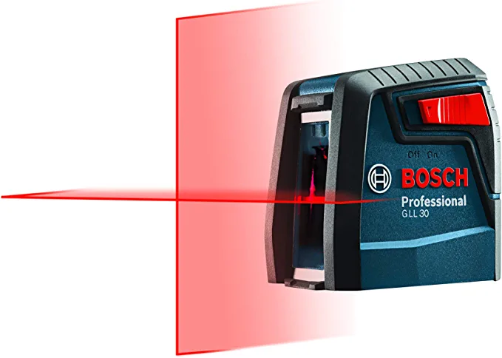

# Item Description: BOSCH GLL30 30ft Cross-Line Laser Level Self-Leveling with 360 Degree Flexible Mounting Device

* FUNCTIONALITY: This laser features a cross-line mode, projecting 2 very bright laser lines, making a Cross Line projection for an array of level and align uses; for install or bathroom remodel
* ACCESSIBLE: Ideal for homeowners and small remodeling jobs such as hanging pictures or installing shelves as an entry-level, easy-to-use tool, wherever leveling or alignment is needed
* DEPENDABLE: This convenient laser’s smart pendulum system allows it to self level while also indicating out of level condition to help ensure correctness; it locks when in transit so it’s secure
* ACCURATE: The Bosch GLL30 laser's thin lines are highly visible up to 30 ft. and offer accuracy of 5/16 inch at 30 ft. so it offers reliable confidence
* COMPACT: Features small dimensions, light weight, and an ergonomic, handy, pocket size design so the GLL30 can fit in any pocket and is easily transportable

Includes: Laser Level, mounting device, instruction manual

Replacement Cost: $50

# Electricity Usage Monitor

# Item #27

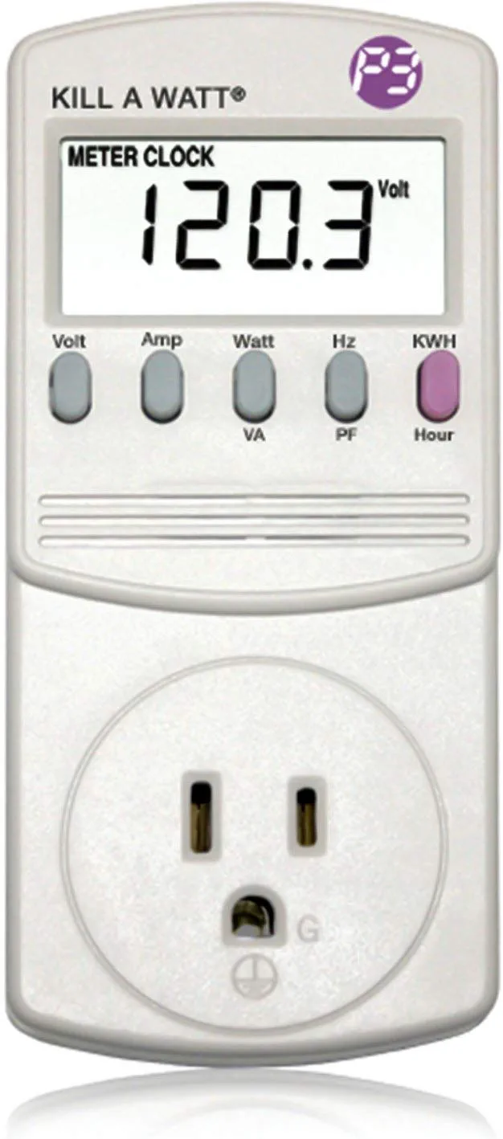

# Item Description: P3 P4400 Kill A Watt Electricity Usage Monitor

* Choose from the Kill-a-Watt's four settings to monitor your electrical usage
* Monitor your electrical usage by day, week, month, or year
* Features easy-to-read screen
* Electricity usage monitor connects to appliances and assesses efficiency
* Large LCD display counts consumption by the kilowatt-hour
* Calculates electricity expenses by the day, week, month, or year
* Displays volts, amps, and wattage within 0.2 - 2.0percent accuracy
* Compatible with inverters; designed for use with AC 115-volt appliances

Includes: Electricity Usage Monitor, Operation Manual

Replacement Cost: $29

# Stud Finder

# Item #28

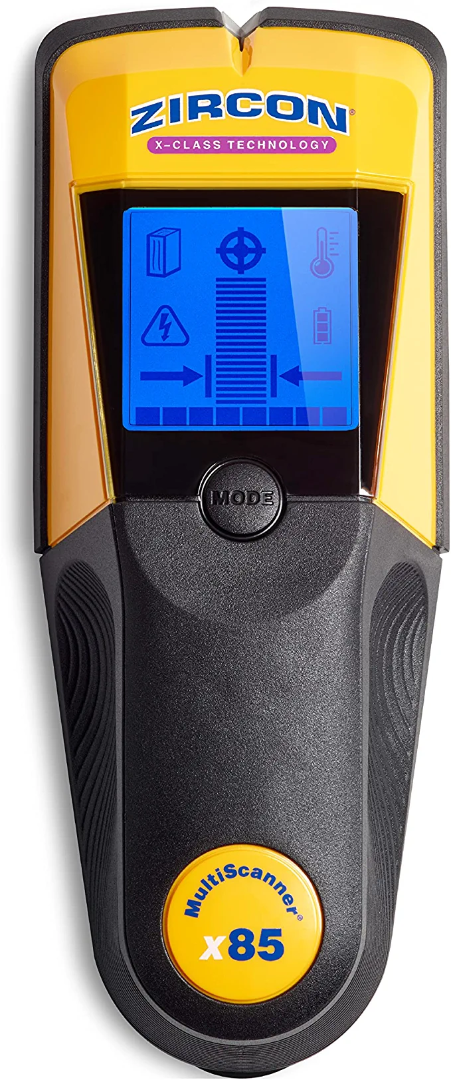

# Item Description: Zircon x85 Center Finding Stud Finder with AC"Live Wire" Detection and Thermal Wall Scanner for Detecting Water-Filled PEX Tubing up to 2 inches Deep

* Finds the center, edges, and direction of wood and metal studs up to 2 in. (50 mm) deep
* Thermally detects actively heated 1/2 in. diameter water-filled pex tubing up to 2 in. deep
* Find and map live unshielded electrical AC wiring up to 2 in. deep
* Backlit LCD screen and patented ergonomic pivot pinch grip for comfortable scanning and viewing from all angles

Includes: Stud Finder, Operating Manual

Replacement Cost: $119

# Portable Podium

# Item #29

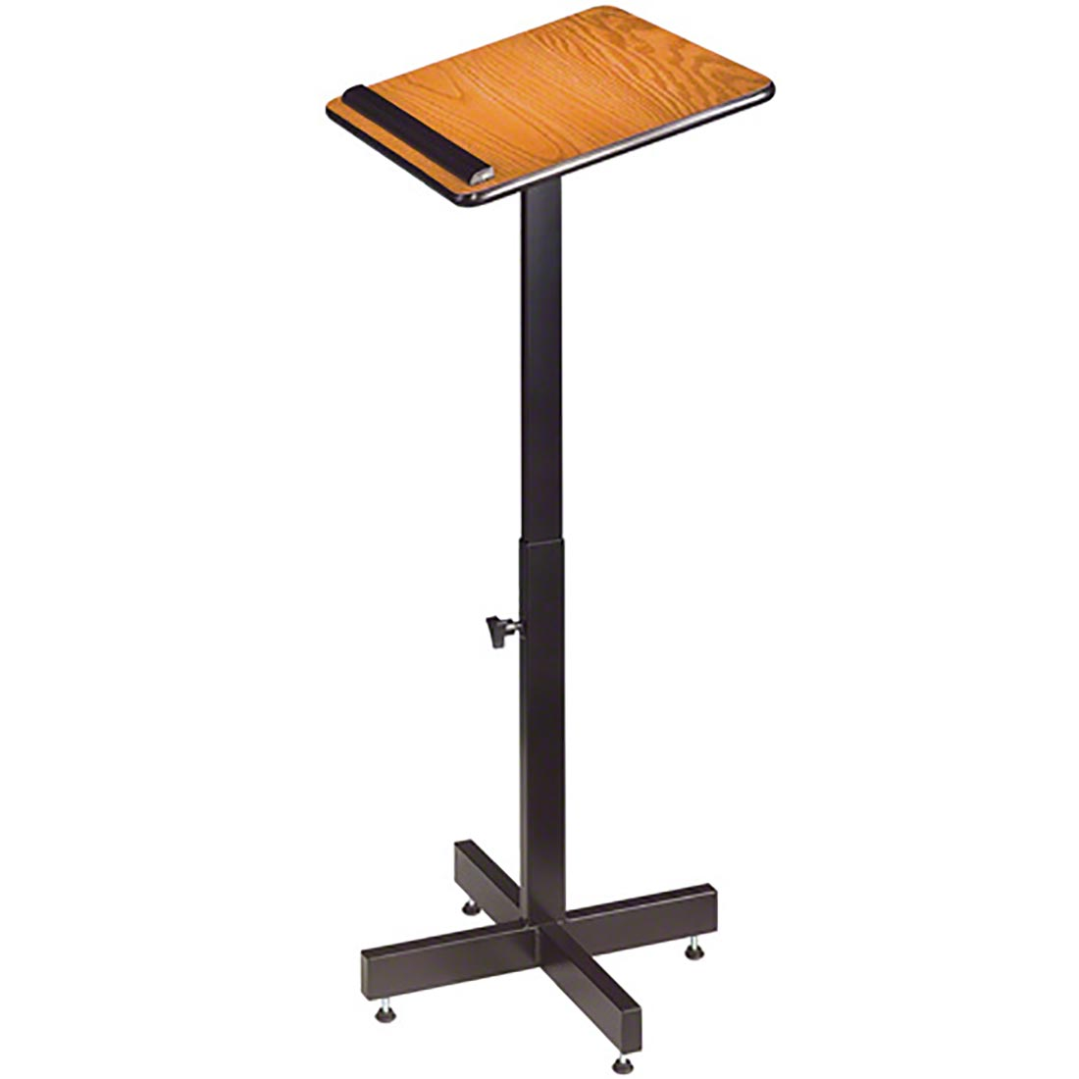

# Item Description:

* Adjustable Height

Includes: Portable Podium

Replacement Cost: $80

# Mint Vintage Style Patio Cooler

# Item #30

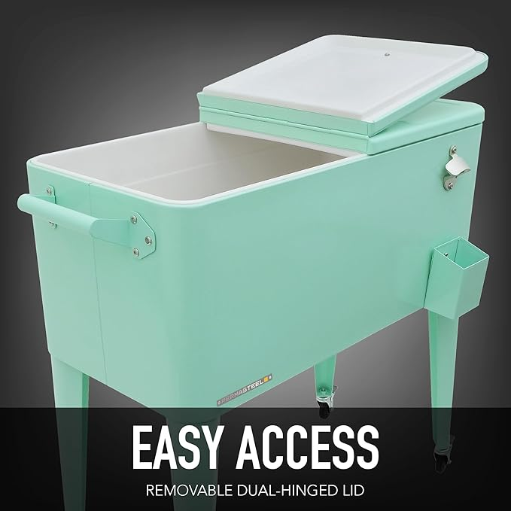

# Item Description: 80 quart Patio Cooler

* Solid construction, powder-coated steel is scratch and rust-resistant.
* Holds up to 110 12-oz cans
* Insulated basin keeps your beverages cold for up to 36 hours.
* With this bar-style cart, open cold drinks without a separate utensil and use the cap catcher not to lose any caps.
* The fully removable lid makes it easy to access your cold drinks. The drain allows emptying the cooler after use.

Includes: 80 quart cooler, hinged lid

Replacement Cost: $250

*Note that there is a dent in the cooler

# Photo Card Reader

# Item #31

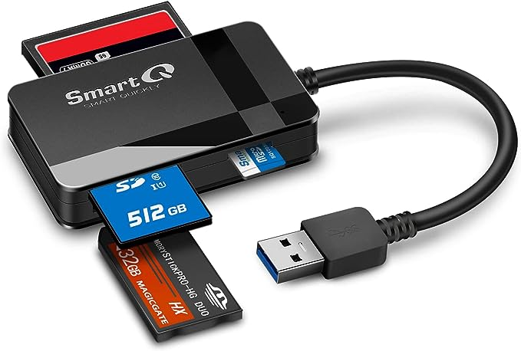

# Item Description:

* SmartQ C368 USB 3.0 Card Reader: Four-in-one design, support Micro SD/SD/MS/CF card and read data independently;
* High data transfer speed, Supporting data transfer speed up to 5GB per second (at USB 3.0 speed)
* Multi-system compatibility, Compatible with Windows/Mac OS/Linux and other systems, no driver needed, enjoy Plug N Play experience

Includes: Card Reader, Case

Replacement Cost: $17

# Binoculars

# Item #32

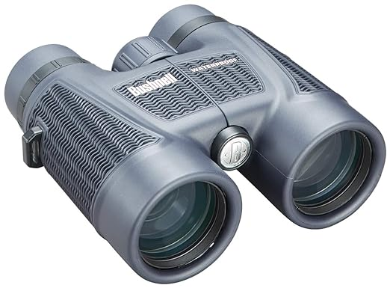

# Item Description:

# Bushnell Binoculars, 8X42, waterproof

Includes:

* Bushnell H20 Roof Prism binocular
* Lens covers – 2 top and 2 bottom
* Cleaning cloth
* Neck strap
* Carrying strap
* Carrying case
* Instruction Manual

Replacement Cost: $80

# Folding Chairs

# Item #33

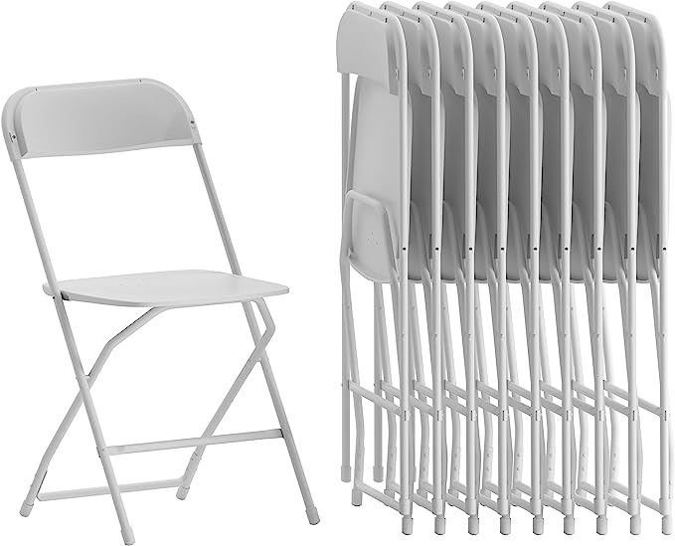

# Item Description:

White Stackable Chairs with 650-lb. Static Weight Capacity

Includes:

* 20 chairs available

Replacement Cost: $15 each chair

# Folding Table

# (10 available)

# Item #34

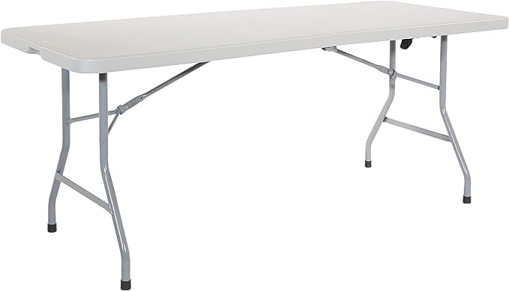

# Item Description:

* 6 foot folding table features a heavy-duty blow-mold light grey resin top
* Measures 72" W x 29.5" D x 28.75" H
* multipurpose table ideal for indoor or outdoor use
* lightweight portability, 31 lb weight
* The center fold table includes a locking latch design along with a handy built-in handle for easy set-up and transportation

Replacement Cost: $50 each table

# Card Table

# (2 available)

# Item #35

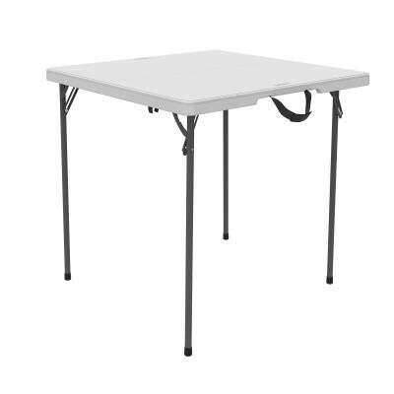

# Item Description:

# 37-inch square Center-Folding Portable Table

# 29-inch height

# 20.6 lb., easy to carry handle

# Steel frame

Replacement Cost: $35 each table

# Blu-ray/DVD Player

# Item #36

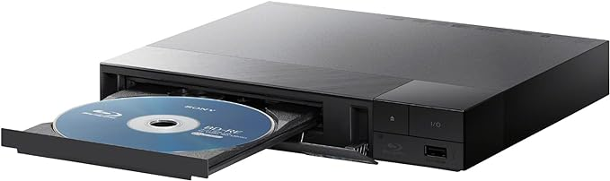

# Item Description:

Sony BDP-BX370 Streaming Blu-ray DVD Player with built-in Wi-Fi, Dolby Digital TrueHD/DTS and upscaling, with included HDMI cable

Includes:

* Blu-ray/DVD Player
* Power Cord
* Remote Control
* HDMI Cable
* Instruction Manual

Replacement Cost: $88

# 10” Portable DVD Player

# Item #37

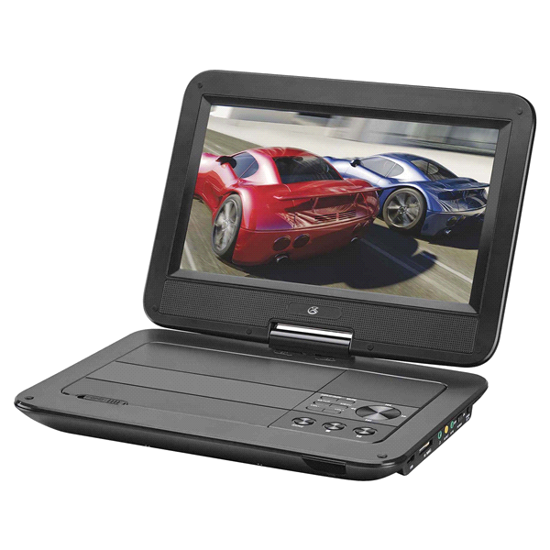

# Item Description:

Perfect for long road trips or home. The 10” LCD screen produces sharp, colorful images. Power adapters for home, car, and a built-in rechargeable battery are included.

Includes:

* 10” DVD Player
* Remote Control
* 3.5 to RCA AV cable
* AC/DC power adaptor
* 12V DC car adapter
* Headphone splitter (patron provides their own headphones)
* Instruction Manual

Replacement Cost: $95

# Portable CD Player

# Item #38

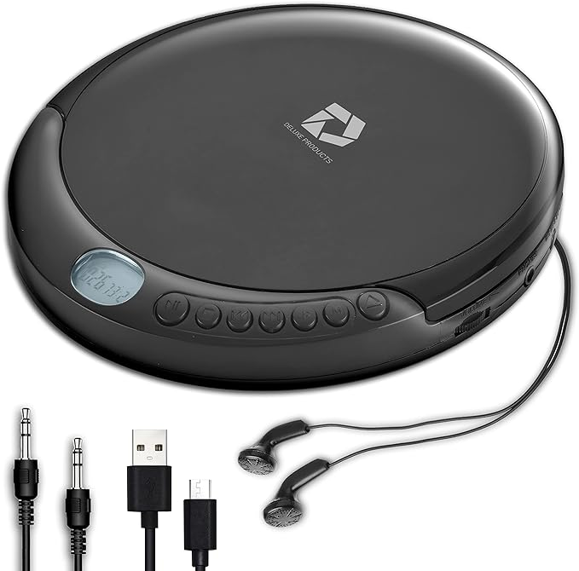

# Item Description:

Deluxe Products CD Portable Player with 60 Second Anti Skip

Includes:

* Portable CD Player
* 3.5MM AUX in cable (patron provides their own headphones)
* Micro USB cable
* Instruction Manual

Replacement Cost: $22

# Folding Hand Truck

# Item #39

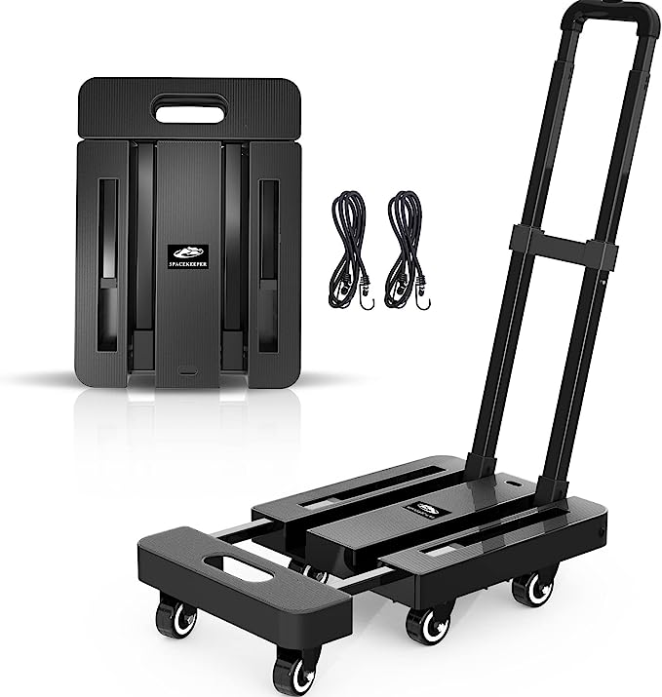

# Item Description:

Folding Hand Truck, 500 LB Heavy Duty Luggage Cart, Utility Dolly Platform Cart

Includes:

* Luggage Cart with 6 wheels
* 2 Bungee cords

Replacement Cost: $50

# Flatbed Photo Scanner

# Item #40

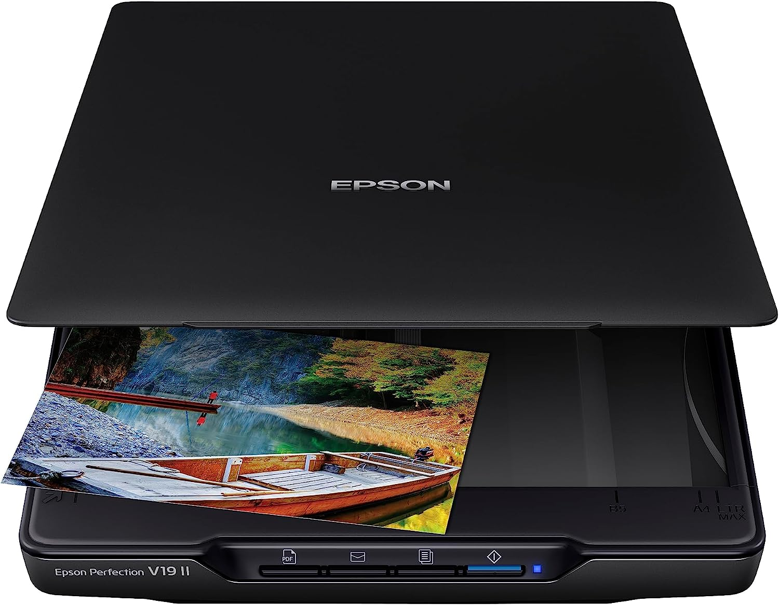

# Item Description:

Color Photo and Document flatbed scanner

Includes:

* Flatbed Scanner
* USB cord
* Instruction Manual

Replacement Cost: $90

# Digital Night Vision Goggles

# Item #41

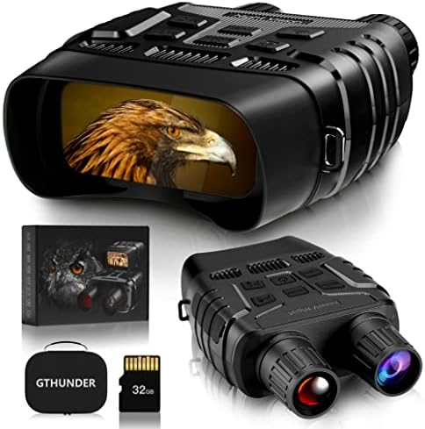

# Item Description:

Digital Night Vision Goggles with Case

Includes:

* Night Vision Scope
* Case
* Neck Strap
* 32 GB SD Memory Card
* USB Data Cable
* User Manual
* Cleaning Cloth

Replacement Cost: $166

# Label Maker

# Item #42

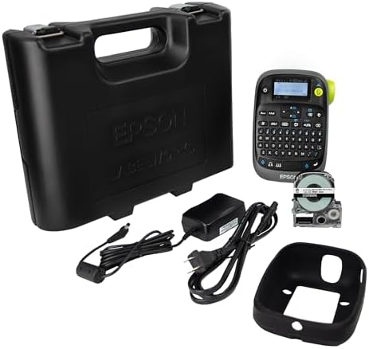

# Item Description:

Epson Labelworks Industrial Label Maker Complete Kit

Includes:

* Industrial Case
* LW-PX300 Printer
* Drop-Guard Sleeve (rubber sleeve around printer)
* AC Power Adapter
* 1 tape
* User Guides (two guides - English and Spanish)

Replacement Cost: $90

# Tool Kit

# BLACK+DECKER 12-Volt MAX Lithium Drill And 59-Piece Project Kit, BDCDD12PK Tool Sets - image 1 of 8Item #43

# Item Description:

Black and Decker Complete Project Tool Kit

Includes:

Cordless Drill/Driver Flat Head Screwdriver

12V Max Lithium Ion Battery Phillips Head Screwdriver

Charger Utility Knife

Storage Bag Ratcheting Screwdriver

Tape Measure Magnetic Bit Tip Holder

6-inch Level 4 Nut Drivers

6-inch Adjustable Wrench 10 General Purpose Drill Bits

Slip Joint Pliers 32 1-inch Screwdriver Bits

Hammer Instruction Manual

Replacement Cost: $70

# Microscope Set

# Item #44

# https://m.media-amazon.com/images/I/71GTm2JktFL._AC_SX679_.jpg

# Item Description: AmScope 120X-1200X Kids Beginner Microscope

Includes:

* Carrying Box
* White Metal Body Microscope
* Tweezers
* 2 collecting vials
* 5 prepared slides/7 blank slides
* Petri Dish
* Graduated Cylinder
* Stirring Rod
* Needle
* Scalpel
* Replacement Light Bulb
* 20X eyepiece
* Cover slips
* User Guide

Replacement Cost: $42

# Cornhole Game

# Item #45

# https://f.media-amazon.com/images/I/7149hgoGCxL._AC_SX679_.jpg

# Item Description: Portable PVC framed Cornhole Game Set

Includes:

* Blue Storage Bag
* 8 Bean Bags
* 2 8-section pipes
* 2 1-section pipes
* 2 3-section pipes

Replacement Cost: $36

# Washer Toss Game

# Item #46

# https://f.media-amazon.com/images/I/910mtggVzBL._AC_SX466_.jpg

# Item Description: Portable Washer Toss Game Set

Includes:

* 2 wooden washer targets
* 4 blue washers
* 4 red washers
* Game rules

Replacement Cost: $50

# Ladder Toss Game

# Item #47

# https://f.media-amazon.com/images/I/81IAashGgTL._AC_SX466_.jpg

# Item Description: Portable Ladder Toss Game Set

Includes:

* Game Instructions
* Carrying Case
* 3 red bolas
* 3 blue bolas
* 6 long white tubes
* 20 short white tubes
* 2 long blue tubes
* 2 long red tubes
* 6 blue and 6 red edge connectors
* 6 blue and 6 red tube connectors

Replacement Cost: $40

# Portable Cassette Player/Recorder

# Item #48

# https://m.media-amazon.com/images/I/618hMbPKjQL._AC_SL1000_.jpg

# Item Description:

Cassette Player/Recorder with freestanding Microphone

Includes:

* Cassette Player
* Freestanding Microphone
* 120 V AC Adaptor
* User Manual

Replacement Cost: $20

# Portable Garment Steamer

# Item #49

# HiLIFE Steamer for Clothes, Portable Handheld Design, 240ml Big Capacity, 700W, Strong Penetrating Steam, Removes Wrinkle, fo

# Item Description:

# HiLIFE Steamer for Clothes, Portable Handheld Design, 240ml Big Capacity, 700W, Strong Penetrating Steam, Removes Wrinkle, for Home, Office (ONLY FOR 120V)

Includes:

* Steamer (Main Machine)
* Steam Nozzle
* Measuring Cup
* Two Fabric Brushes
* Instruction Manual

Replacement Cost: $30

# Home Radon Detector

# Item #50

# https://m.media-amazon.com/images/I/71xTKuK7zHL._SL1500_.jpg

# Item Description:

# Airthings Corentium Home Radon Detector 223 Portable, Lightweight, Easy-to-Use, (3) AAA Battery Operated, USA Version, pCi/L

Includes:

* Radon Detector Unit
* User Manual

Replacement Cost: $115